**Universidade Federal do Piauí**

**Educação Ciências Artes Inclusão Social**

**ESTÁGIO EM FISIOTERAPIA NEUROLÓGICA NO ADULTO**

**AVALIAÇÃO FISIOTERAPÊUTICA – Paralisia Facial**

Data da Avaliação: _____________________

**I. DADOS PESSOAIS**

Nome: ____________________________________________________ Sexo: ____________

Endereço:___________________________________________________________________

Cidade/UF:__________________________________________________________________

Telefones: __________________________________________________________________

Data de Nascimento: ________________ Idade:_______ Estado Civil: __________________

Profissão: ______________________________ ( ) Atuante ( ) Afastado ( ) Aposentado

Médico responsável: __________________________________________________________

Diagnóstico Médico: __________________________________________________________

Acompanhante: ______________________________________________________________

**II. ANAMNESE:**

Queixa Principal

_________________________________________________________________________________________________________________________________________________________________________________________________________________________________

H.M.A / H.M.P

________________________________________________________________________________________________________________________________________________________________________________________________________________________________________________________________________________________________________________________________________________________________________________________________________________________________________________________________________________________________________________________________________________________________________________________________________________________

Exames Complementares e Cirurgias

__________________________________________________________________________________________________________________________________________________________________________________________________________________________________________________________________________________________________________

Medicação Atual

____________________________________________________________________________________________________________________________________________________________________________________________________________________________________________________________________________________________________________

**III. EXAME FÍSICO**

Sinais Vitais: PA: ____________________ FC:__________________ FR: ______________

Tipo de paralisia facial: ( ) Periférica ( ) Central

( ) Direita ( ) Esquerda ( ) Bilateral - ( ) Paresia ( )Plegia

Lagoftalmo: ( ) Presente ( ) Ausente

Sinal de Bell: ( ) Presente ( ) Ausente

Epifora: ( ) Presente ( ) Ausente

Sincinesias (contrações involuntárias da face): ( ) Presente ( ) Ausente

Disartria: ( ) B ( ) P ( ) M ( ) V

Desvio do traço fisionômico para o lado não afetado? ( ) Sim ( ) Não

Sulcos na pele do lado comprometido? ( ) Pronunciados ( ) Não pronunciados

( ) Alteração do trofismo:_____________________________________________________

( ) Alteração do tônus: _______________________________________________________

**FORÇA MUSCULAR**

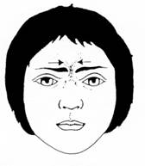

Músculo Corrugador do Supercílio

|  |  |  |  |  |  |
| --- | --- | --- | --- | --- | --- |
| 0 | 1 | 2 | 3 | 4 | 5 |

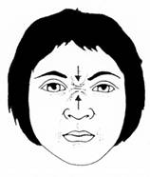

Músculo Prócero elevador da asa do nariz

|  |  |  |  |  |  |
| --- | --- | --- | --- | --- | --- |
| 0 | 1 | 2 | 3 | 4 | 5 |

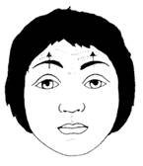

Músculo Frontal

|  |  |  |  |  |  |
| --- | --- | --- | --- | --- | --- |
| 0 | 1 | 2 | 3 | 4 | 5 |

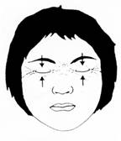

Abrir os olhos: Músculo Levantador da pálpebra superior

|  |  |  |  |  |  |
| --- | --- | --- | --- | --- | --- |
| 0 | 1 | 2 | 3 | 4 | 5 |

Fechar os olhos: Músculo Orbicular dos olhos

|  |  |  |  |  |  |
| --- | --- | --- | --- | --- | --- |
| 0 | 1 | 2 | 3 | 4 | 5 |

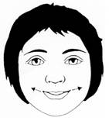

Músculo Risório

|  |  |  |  |  |  |
| --- | --- | --- | --- | --- | --- |
| 0 | 1 | 2 | 3 | 4 | 5 |

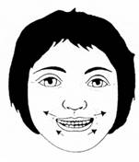

Músculo Zigomático

|  |  |  |  |  |  |
| --- | --- | --- | --- | --- | --- |
| 0 | 1 | 2 | 3 | 4 | 5 |

Encher a boca de ar: Músculo Bucinador

|  |  |  |  |  |  |
| --- | --- | --- | --- | --- | --- |
| http://paralisiafacial.com/assets/paralisia-facial-fisioterapia_clip_image014.jpg0 | 1 | 2 | 3 | 4 | 5 |

Assobiar: Orbicular da boca

|  |  |  |  |  |  |
| --- | --- | --- | --- | --- | --- |
| 0 | 1 | 2 | 3 | 4 | 5 |

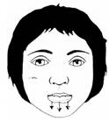

Musculo Depressor do ângulo inferior da boca e do lábio inferior

|  |  |  |  |  |  |
| --- | --- | --- | --- | --- | --- |
| 0 | 1 | 2 | 3 | 4 | 5 |

**AVD’S**

Ingesta liquida: _____________________________________________________________________

Ingesta sólida: ______________________________________________________________________

**OBSERVAÇÕES GERAIS:**

____________________________________________________________________________________________________________________________________________________________________________________________________________________________________________________________________________________________________________

**CONCLUSÕES:**

____________________________________________________________________________________________________________________________________________________________________________________________________________________________________________________________________________________________________________

**OBJETIVOS:**

_________________________________________________________________________________________________________________________________________________________________________________________________________________________________________________________________________________________________________________________________________________________________________________________________________________________________________________________________________________________________________________________________________________________________________________________________________________________________________________________________________________________________________________________________________________________________________________________________________________________________________________________

**CONDUTAS:**

__________________________________________________________________________________________________________________________________________________________________________________________________________________________________________________________________________________________________________________________________________________________________________________________________________________________________________________________________________________________________________________________________________________________________________________________________________________________________________________________________________________________________________________________________________________________________________________________________________________________________________________________________________________________________________________________________________________________________________________________________________________________________________________________________________________________

____________________________________ ______________________________

ESTAGIÁRIOS SUPERVISORES